Regulations:
A14

H.T No

Sreenidhi Institute of Science and Technology
(An Autonomous Institution)
Code No: 4AC41 Date: 22-June-2019 (AN)

B.Tech II-Year I-Semester External Examination, June-2019 (Supplementary)
Basic Electrical Engineering (ME, CSE and IT)

Time: 3 Hours Max.Marks:70

Note: a) No additional answer sheets will be provided.
b) All sub-parts of a question must be answered at one place only, otherwise it will not be valued.
c) Missing data can be assumed suitably.

Part - A Max.Marks:20

Answer all QUESTIONS.

1. | Give the classification of active elements. | [2M]
2. | Capacitors 2uF , 5uF and 10uF are connected in parallel. Determine the effective capacitance and reactance if supply frequency is 60Hz. | [2M]
3. | Explain the term average value of an alternating quantity. | [2M]
4. | Explain the term Form factor with an example. | [2M]
5. | What are the characteristics and applications of DC Shunt motor ? | [2M]
6. | What are the effects of armature reaction in a DC Generator? | [2M]
7. | What is the difference between an ideal transformer and a practical transformer. | [2M]
8. | What is regulation in a transformer. Give the Expression for it. | [2M]
9. | List the requirements of a measuring instrument. | [2M]
10. | Give the relations for Line and Phase currents for a balanced star connected system. | [2M]
Part – B Max.Marks:50
ANSWER ANY FIVE QUESTIONS. EACH QUESTION CARRIES 10 MARKS.

11. | a) | State and explain Maximum Power Transfer Theorem with an example. | [4M]
 | b) | Find the voltage across 2Ω in the figure using Superposition Theorem.  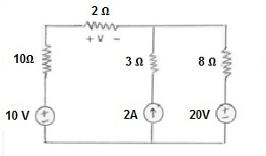 | [6M]
12. | a) | Derive the Expressions for Average and RMS Values for a sine wave. | [5M]
 | b) | State and Explain Faraday’s laws of Electromagnetic Induction. | [5M]
13. | a) | Derive the EMF equation of a DC Generator. | [4M]
 | b) | An 8-pole DC generator has 500 armature conductors and a useful flux of 0.06Webers/pole. What is the e.m.f generated if it runs at 1200rpm and conductors are lap wound. At what speed must it be run to produce the same voltage if it is wave wound. | [6M]
14. | a) | What are the losses in a transformer? How can these losses be determined experimentally? | [6M]
 | b) | A single phase 1100V/220V transformers under test gave the following test results.  OC Test : 1100V, 0.5A, 55W  SC Test : 10V, 80A, 400W on LV side, HV Short circuited.  Calculate the efficiency of the transformer when the secondary supplies 100A at 0.8pf lag. | [4M]
15. | a) | Explain the working principle of a 3-Phase Induction motor. | [6M]
 | b) | A 4-pole 3-Phase induction motor runs at 1750rpm. What is the frequency of rotor currents, if supply frequency is 60Hz. | [4M]
16. | a) | Explain the function of deflecting torque, control torque and damping torque in a moving coil instrument | [5M]
 | b) | With the help of a neat sketch explain the working of an Attraction type Moving Iron Instrument. | [5M]
17. | a) | Calculate the Equivalent resistance between terminals B and C in the figure shown below.  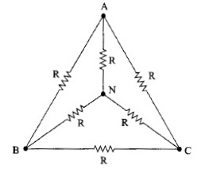 | [5M]
 | b) | Draw the no load phasor diagram of a transformer and derive expressions for magnetizing and core loss components of no load current. | [5M]
18. | a) | Explain the torque slip - characteristics of a 3 –phase induction motor. | [5M]
 | b) | Explain with a neat diagram how the range of a moving coil ammeter can be extended. | [5M]
-- 00 -- 00 –

